1. **Description about each part of the house**
2. **Description about each part of the house**

**Living Room**Six 10W LED lamps  
Two 10W wall lamps  
Four 13 A plug sockets   
One 75 W ceiling fan

**Dining and Pantry**Two 5W LED lamps  
Two 10W LED lamps  
One 15W LED lamp  
Four 13 A plug sockets  
One 75 W ceiling fan  
One 2kW Oven  
One 2kW Rice Cooker  
150W Fridge

**Bedroom 1**One 10 W LED lamps   
One 13 A plug sockets  
One 75W Fan

**Bedroom 2**One 10 W LED lamps   
One 13 A plug sockets  
One 75W Fan

**Bedroom 3**Two 10 W LED lamps   
Two 13 A plug sockets  
Two 5W LED lamps  
One 1.2kW A/C

**Toilet**One 10W LED lamp  
One 5W LED lamp  
One 1 kW instantaneous water heater  
Two 13A plug sockets

**Garage**Two 10W LED lamp  
One 15W LED lamp  
Two 13A plug sockets

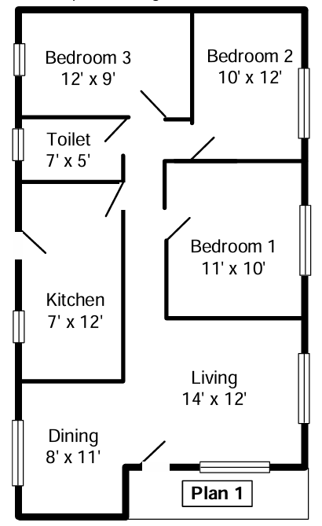

|  |  |  |
| --- | --- | --- |
| **Circuit No** | **Ring / Radial** | **Description** |
| ***Lighting*** | | |
| 1 | Radial | * One 10 W LED lamps in bedroom 1 * One 10 W LED lamps in bedroom 2 * Two 10W and 5W LED lamps in bedroom 3 |
| 2 | Radial | * Two 5W LED lamps in the dining & pantry * Two 10W LED lights in dining & pantry * One 15W LED lamp in the dining & pantry |
| 3 | Radial | * One 10W LED and One 5W LED in Toilet * Two 10W LED and 5W wall lamp in the Corridor |
| 4 | Radial | * Six 10W LED lamps and two 5W wall lamps |
| 5 | Radial | * Two 10W LED lamps and one 15W lamps |
| ***Socket Outlets*** | | |
| 6 | Ring | * One 13A socket in bedroom 1 * One 13A socket in bedroom 2 * Two 13A sockets in bedroom 3 * Two 13A sockets in toilet |
| 7 | Radial | * Four 13A sockets for dining & pantry * Four 13A sockets in living room * Two 13A sockets in garage |
| 8 | Radial | * A dedicated socket for 150W fridge in the kitchen |
| 9 | Radial | * A dedicated socket for 2kW oven in the kitchen |
| 10 | Radial | * A dedicated socket for 2kW rice cooker in the kitchen |
| 11 | Radial | * A dedicated socket for 1kW instantaneous water heater in the toilet |
| 12 | Radial | * A dedicated socket for 1.2kW A/C in the bedroom 3 |
| Ceiling fan circuits | | |
| 13 | Radial | * One 75 W ceiling fan in living room * One 75 W ceiling fan in dining & pantry * One 75 W ceiling fan in bedroom 1 * One 75 W ceiling fan in bedroom 2 |

**2. Description of circuit sub-divisions**

**3. Diversity factors ,Max current and MCB rating demand in each circuit**

|  |  |  |  |
| --- | --- | --- | --- |
| Circuit Number | Calculation considering the Diversity factors | Max current demand/A | MCB rating/A |
| 1 | $$0.66\left(\frac{ 4×20 W+ 2×5 W}{230 V}\right)$$ | 0.26 | 6 |
| 2 | $$0.66\left(\frac{ 1×15 W+ 4×10 W+2×5 W}{230 V}\right)$$ | 0.19 | 6 |
| 3 | $$0.66\left(\frac{ 3×10 W+2×5 W}{230 V}\right)$$ | 0.11 | 6 |
| 4 | $$0.66\left(\frac{6×10 W+2×10 W}{230 V}\right)$$ | 0.23 | 6 |
| 5 | $$0.66\left(\frac{ 1×15 W+ 2×10 W}{230 V}\right)$$ | 0.10 | 6 |
| 6 | - | - | 32 |
| 7 | - | - | 32 |
| 8 | $$\frac{ 150 W}{230 V}$$ | 0.65 | 6 |
| 9 | $$\frac{ 2000W}{230 V}$$ | 8.70 | 10 |
| 10 | $$\frac{ 2000 W}{230 V}$$ | 8.70 | 10 |
| 11 | $$\frac{ 1000 W}{230 V}$$ | 4.35 | 10 |
| 12 | $$\frac{ 1200 W}{230 V}$$ | 5.22 | 6 |
| 13 | $$\frac{4×75 W }{230 V}$$ | 1.30 | 6 |

**4. RCCB Selection**

|  |  |
| --- | --- |
| RCCB | Assigned circuits to the RCCB |
| 40A, 30mA | 1 |
| 2 |
| 3 |
| 4 |
| 5 |
| 6 |
| 40A, 30mA | 9 |
| 10 |
| 11 |
| 12 |
| 40A, 30mA | 7 |
| 8 |
| 13 |

**5. Wire Sizes**

$$CCC> \frac{MCB Rating}{C_{t}×C_{g}}$$

|  |  |  |  |  |  |  |  |
| --- | --- | --- | --- | --- | --- | --- | --- |
| Circuit Number | Number of circuits in the conduit | Cg | Minimum CCC / A | Maximum wire length/m | Voltage drop / V | L and N Conductor size (mm2) | Protective conductor size (mm2) |
| 1 |  | 0. |  |  |  | 1.0 | 1.0 |
| 2 |  | 0. | $$\frac{6}{0.94×0.7}=9.119$$ |  | $$44×{10}^{-3}×30×0.19=1.072$$ | 1.0 | 1.0 |
| 3 |  | 0. | $$\frac{6}{0.94×0.8}=21.277$$ |  | $$18×{10}^{-3}×11×0.11=2.574$$ | 2.5 | 2.5 |
| 4 |  | 0. | $$\frac{6}{0.94×0.8}=21.277$$ |  | $$18×{10}^{-3}×12×0.23=3.024$$ | 2.5 | 2.5 |
| 5 |  | 0. | $$\frac{6}{0.94×0.8}=21.277$$ |  | $$18×{10}^{-3}×9×0.10=1.944$$ | 2.5 | 2.5 |
| 6 |  | - | - |  | - | 2.5 | 2.5 |
| 7 |  | - | - |  | - | 2.5 | 2.5 |
| 8 |  | 0. | $$\frac{6}{0.94×0.8}=21.277$$ |  | $$18×{10}^{-3}×10×0.65=2.160$$ | 2.5 | 2.5 |
| 9 |  | 0. | $$\frac{10}{0.94×0.8}=21.277$$ |  | $$18×{10}^{-3}×6×8.70=0.704$$ | 2.5 | 2.5 |
| 10 |  | 0. | $$\frac{10}{0.94×0.7}=9.119$$ |  | $$44×{10}^{-3}×5×8.70=0.957$$ | 1.0 | 1.0 |
| 11 |  | 0. | $$\frac{6}{0.94×0.8}=21.277$$ |  | $$18×{10}^{-3}×8×4.35=1.565$$ | 2.5 | 2.5 |
| 12 |  | 0. | $$\frac{6}{0.94×0.7}=9.119$$ |  | $$44×{10}^{-3}×22×5.22=0.087$$ | 1.0 | 1.0 |
| 13 |  | 0. | $$\frac{6}{0.94×0.7}=9.119$$ |  | $$44×{10}^{-3}×22×1.30=0.087$$ |  |  |

* Allowable voltage drop is 3%. Therefore, allowable voltage drop = $230 V ×0.03$ = 6.9 V
* Ambient temperature factor was taken as 0.94 at 35 oC

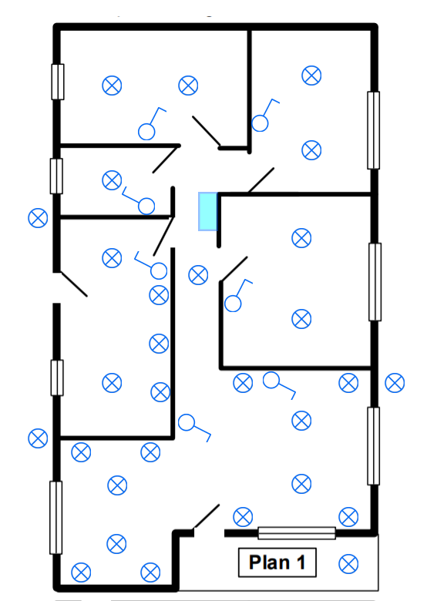**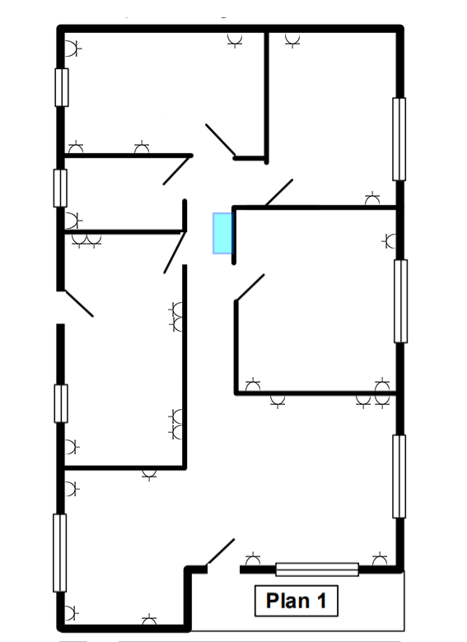­­­­­**

**6,7,8. Lamp, Socket outlet and Fan layouts**

L6

L5

L4

L3

S23

S22

S24

S21

S20

S19

L7

S25

L10

L8

L2

S14

S13

S10

L29

L11

L1

S16

S15

L12

S12

S11

L28

L27

L26

L25

L13

L9

S26

S18

S17

S5

S6

S7

L24

L16

L15

L14

S2

S1

L22

L21

L18

L17

S8

S9

L23

L20

L19

S4

S3

Lamp Layout with Switches

Socket Outlet Layout

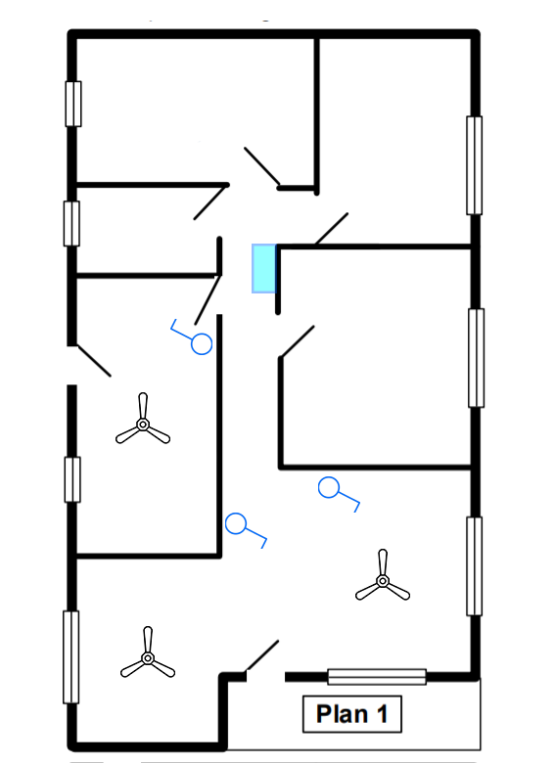

Dedicated circuit

Ring circuit

Radial circuit



Plug socket



LED lamp



Switches

F1

Ceiling Fan



Distribution Box

F3

F2

Fan Layout

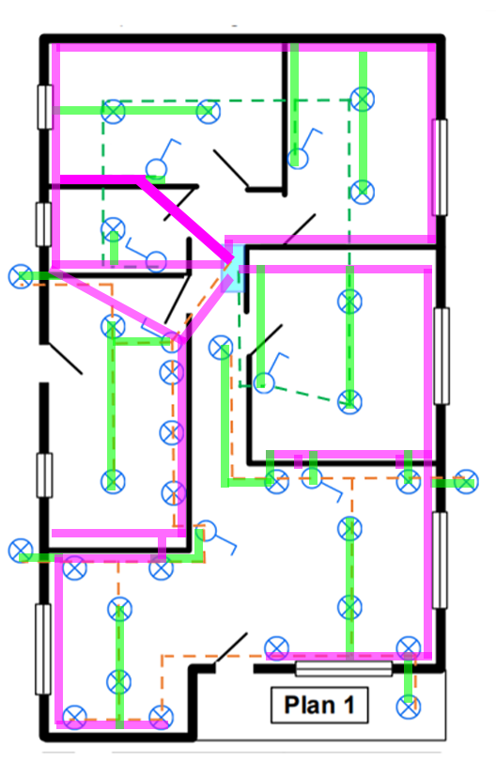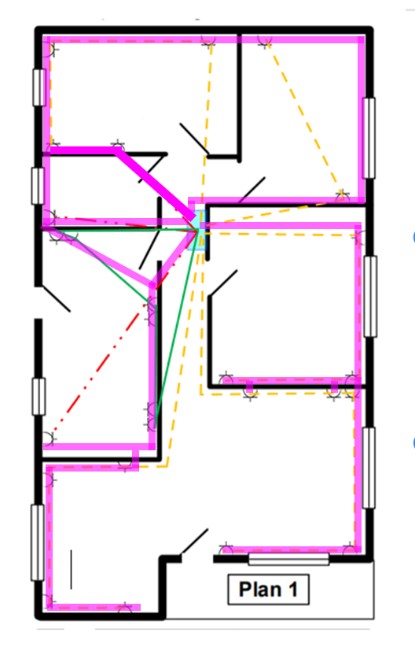

**9 . Conduit layouts**

Final conduit layout

Conduit layout for lights

¾” Conduit

1” Conduit

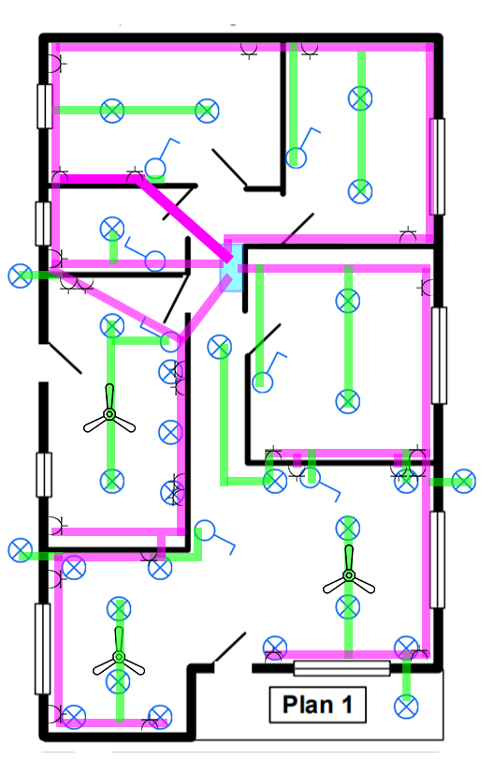

Conduit layout for sockets outlet

Lighting in dining & pantry

Lighting in bedroom 1, bedroom 2, bedroom 3

L and N- 1 mm2

L and N- 2.5 mm2

40A, 30mA RCCB

Lighting in toilet and corridor

L and N- 2.5 mm2

Lighting in living room

L and N- 2.5 mm2

Lighting in garage

L and N- 2.5 mm2

Plug sockets in bedroom1, bedroom2, bedroom3 and toilet

L and N- 1 mm2, E – 2.5 mm2

40A, 1P

L and N- 1 mm2, E – 2.5 mm2

A dedicated line for the 2kW oven in dining & pantry

L and N- 2.5 mm2, E -2.5 mm2

A dedicated line for the 2kW rice cooker in dining & pantry

40A, 30mA RCCB

A dedicated line for the 1kW water heater in toilet

L and N- 2.5 mm2, E - 2.5 mm2

A dedicated line for the 1.2kW Air conditioner in bedroom 3

L and N- 2.5 mm2, E – 2.5 mm2

Plug sockets in dining & pantry, living room, and garage

L and N- 1 mm2, E – 2.5 mm2

A dedicated line for the 150W fridge in dining & pantry

L and N- 2.5 mm2, E -2.5 mm2

40A, 30mA RCCB

Fans in the bedroom 1, bedroom 2, living room, dining & pantry

L and N- 2.5 mm2, E - 2.5 mm2

**Approximate Costs (in rupees)**

*Note that the costs are given in LKR

|  |  |  |  |
| --- | --- | --- | --- |
| 1 mm2 wire (100 m) | Rs. 5000 – single core | Ceiling roses | Rs. 275 |
| 1.5 mm2 wire (100 m) | Rs. 20000 – two core | 13A socket | Rs. 900 |
| 2.5 mm2 wire (100 m) | Rs. 30000 – two core | Switches | Rs. 300 per gang |
| Earth wires (100 m) | Rs. 15000 | MCB | Rs. 800 |
| Fan | Rs.13000 | Conduits 1” | Rs. 750 per m |
| Main switch | Rs. 2500 | Conduits 3/4” | Rs. 500 per m |
| RCCB | Rs. 4800 | Holder | Rs. 225 |
| Bends, Plastic boxes, junction boxes | Rs. 100 | LED lamp | Rs.2000 – 5W wall lamp  Rs.1000 – 5W  Rs.1500 – 10W  Rs.2000 – 15W |

Workmanship fees – Rs.750 per point

**11. Bill Of Quantities (BOQ)**

1. For ring plug circuit

|  |  |
| --- | --- |
|  | For circuit 5 (15m) |
| For plug sockets | 5400 |
| Cost for L and N wires | 9000 |
| Cost for Earth wires | 2250 |
| Cost for conduit (Took 60% of wire length) | 6750 |
| Cost for bends, plastic boxes, junction boxes | 300 |
| Workmanship fees | 750x6 = 4500 |
| Total | 28200 |

Total cost for ring plug circuits = 28200

1. For radial plug circuits

|  |  |  |
| --- | --- | --- |
|  | For circuit 10 (5m) | For circuit 4 (12m) |
| For plug sockets | 900 | 4500 |
| Cost for L and N wires | 500 | 7200 |
| Cost for Earth wires | 750 | 1800 |
| Cost for conduit (Took 60% of wire length) | 2250 | 5400 |
| Cost for bends, plastic boxes, junction boxes | 100 | 200 |
| Workmanship fees | 750 | 3750 |
| Total | 5250 | 22850 |

Average cost = 14050

Total cost for radial plug circuits = 14050 x 8 = 112400

1. For lightening circuits

|  |  |  |
| --- | --- | --- |
|  | For circuit 1 (20m) | For circuit 2 (30m) |
| For lamps | 15800 | 44700 |
| Cost for L and N wires | 2000 | 3000 |
| Holders | 1575 | 4950 |
| Switches and sunk boxes | 1600 | 1200 |
| Ceiling roses | 1925 | 3025 |
| Cost for conduit (Took 60% of wire length) | 6000 | 9000 |
| Cost for bends, plastic boxes, junction boxes | 700 | 1400 |
| Workmanship fees | 750x7 = 5250 | 750x22 = 16500 |
| Total | 34850 | 83775 |

Total cost for lightening circuits = 118625

1. For Fan circuit

|  |  |
| --- | --- |
|  | For circuit 12 (22m) |
| For Fans | 13000 x 3 = 39000 |
| Cost for L and N wires | 2200 |
| Cost for Earth wires | 1000 |
| Switches and sunk boxes | 1200 |
| Cost for conduit (Took 60% of wire length) | 6600 |
| Cost for bends, plastic boxes, junction boxes | 400 |
| Workmanship fees | 750x3 = 2250 |
| Total | 52650 |

Total cost for fan circuits = 52650

**Total cost**

|  |  |
| --- | --- |
| Description | Cost (rupees) |
| Main switch | 2500 |
| Trip switch | 5000 |
| MCB’s | 9600 |
| Radial plug socket circuits | 112400 |
| Ring plug socket circuit | 28200 |
| Lightening circuits | 118625 |
| Fan circuit | 52650 |
| Total Cost | 328975 |

**Total cost = 328,975 LKR**